PRACTICAL 6

AIM: Configure network using Cisco Packet Tracers software and show packet transmission from source to destination.

Screen Shots of packet transmission using HUB:

Step1: Start Packet Tracer

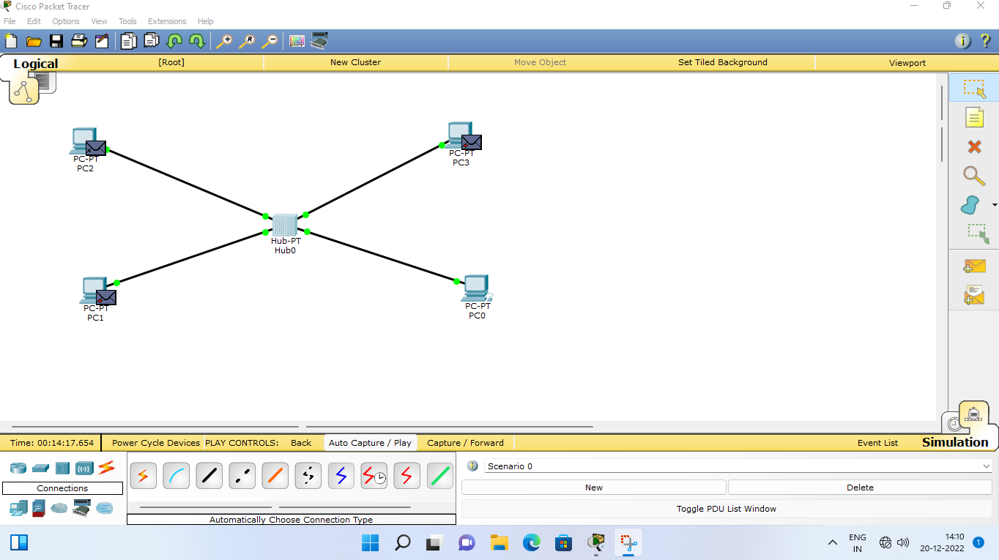

Step 2: Choose “Hub” and then select “Generic”

After selecting “Generic” click on the main area.

Select “End Devices” and then click at “Generic” Click at the workspace to see the PC.

Connect the devices using connections and assign them Ip addresses

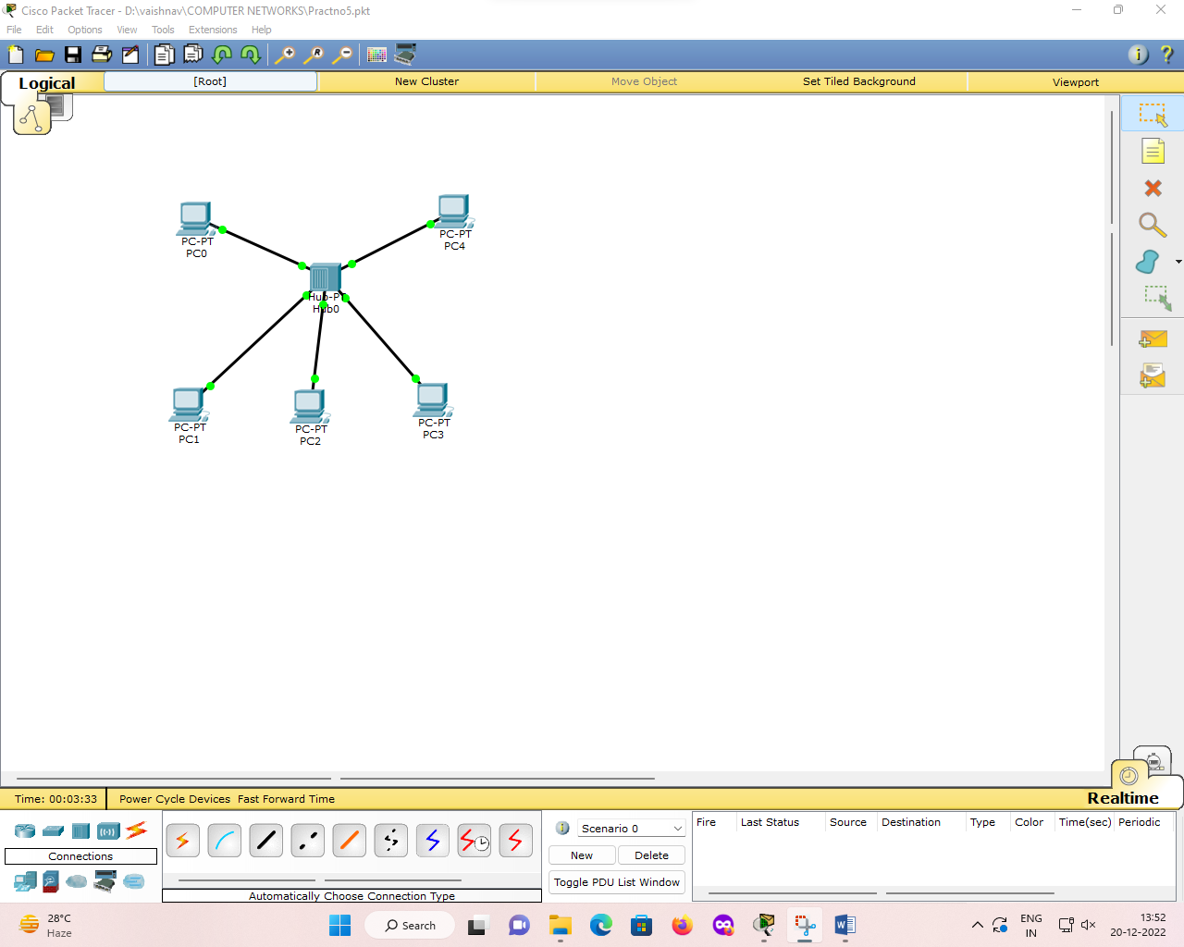

Step 3: Send packets as per your wish.

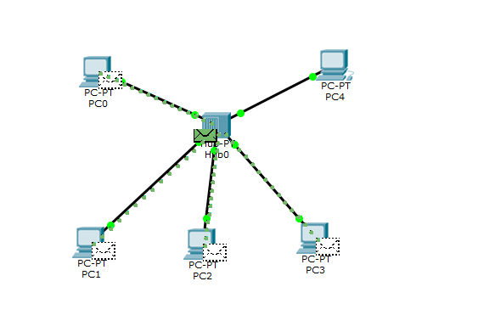

Step 4: Packets reached successfully.

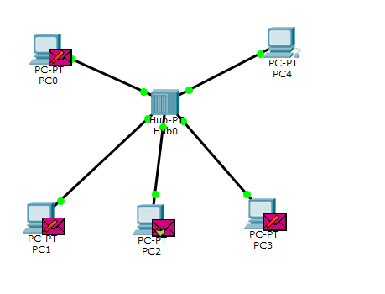

Packet transmission using SWITCH:

Step1: Take a switch🡪 and 4 devices 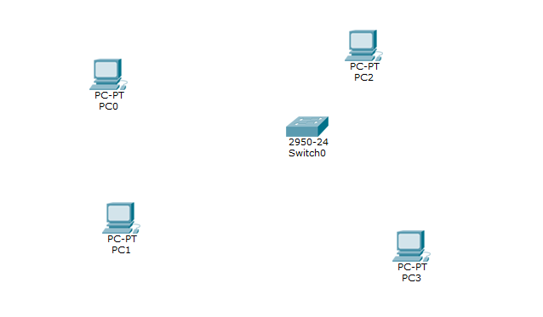

Step 2: Connect the devices using connections. And assign them IP addresses.

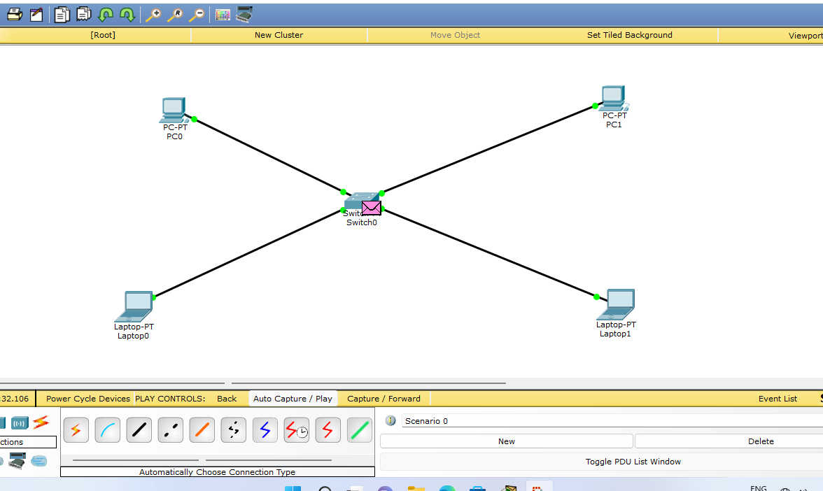

Step 3: Transfer the packets as per your choice within devices.

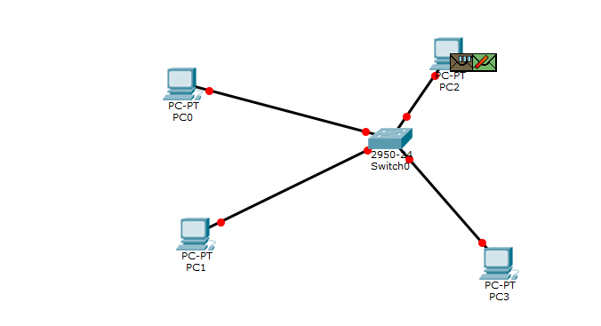

CONCLUSION: Configure network using Cisco Packet Tracers software and show packet transmission from source to destination was performed successfully.